**Epic System Pulse Monitoring Configuration Guide**

This article was updated to support v12.0 and newer of Goliath Performance Monitor.

**Prerequisites**

* Service Account with Read-Only Rights
* HTTPS w/ Username enabled for Outgoing Data Services via Epic System Pulse Configuration Editor
* HTTPS enabled for Incoming Data Services via Epic System Pulse Configuration Editor
* Valid SSL Certificate applied to Epic System Pulse Server
  + A copy of the SSL Certificate (*.cer file) is needed for the configuration
* Epic System Pulse Server Address
* Epic resource group name that you'll be connecting to
* Epic resource type id for the above resource group

**Article Contents**

1. [Testing the Epic System Pulse Connection](https://support.goliathtechnologies.com/hc/en-us/articles/360024294433-Epic-System-Pulse-Monitoring-Configuration-Guide#h_01EM43VT9776N96Y34ZD7F29K9)
   1. [Example Expected Output](https://support.goliathtechnologies.com/hc/en-us/articles/360024294433-Epic-System-Pulse-Monitoring-Configuration-Guide#h_01EMP72TD6YHXJA01247KY1CXQ)
2. [Epic System Pulse Monitoring Configuration](https://support.goliathtechnologies.com/hc/en-us/articles/360024294433-Epic-System-Pulse-Monitoring-Configuration-Guide#h_01EM43VZ2XP7EZWXAMBHZ7FMK9)
   1. [Import Epic System Pulse Certificate](https://support.goliathtechnologies.com/hc/en-us/articles/360024294433-Epic-System-Pulse-Monitoring-Configuration-Guide#h_01GNW9B5WF3BJQNBMJ9CEP6F5E)
   2. [Enable Epic System Pulse Monitoring](https://support.goliathtechnologies.com/hc/en-us/articles/360024294433-Epic-System-Pulse-Monitoring-Configuration-Guide#h_01GNW9BHHK21VVG70NQR8FX7KA)
3. [Post Installation](https://support.goliathtechnologies.com/hc/en-us/articles/360024294433-Epic-System-Pulse-Monitoring-Configuration-Guide#h_01EM43W3HKX97E6PWXVJ8H857W)

**Testing the Epic System Pulse Connection**

Before proceeding with configuring the Epic System Pulse integration, please test your setup outside of the product to confirm all prerequisites have been met.

1. Download and extract the "epicSystemPulseTests" powershell script to the machine that will be hosting the Epic integration for Goliath
   1. [Epic System Pulse Test Script](https://goliathpm.s3.amazonaws.com/Consulting/epicSystemPulseTests.zip)
2. Run the script as admin and follow the below prompts. The script will have two sections worth of prompts and validations:
   1. Confirming it can connect to the Epic System Pulse Server.
      1. Expected Prompts:
         1. Epic System Pulse Server Address
         2. Username of the service account that has rights to Epic
         3. Password of the service account that has rights to Epic
         4. resource type id
         5. resource group name
   2. Confirming it can pull data using the resource group information provided
      1. Expected Prompts:
         1. The host ID(s) for the epic data. Please note, it will list the ones it sees available if there are none available, confirm you have the correct resource group name and resource group id
         2. Start Date/Time for the metric collection (click enter to use the defaults)
         3. End Date/Time for the metric collection (click enter to use the defaults)

**Example Expected Output**

**Testing the Epic System Pulse Connection**

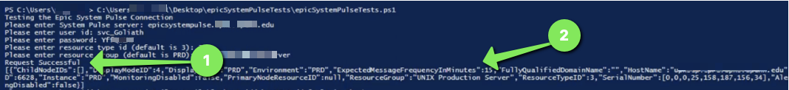

1. If the connection is successful you'll expect to see the text "Request Successful" after entering the "resource group" name. This is shown with call out #1 in the above image.
2. You should also expect to see connection details following the "Request Successful" message. This is shown with call out #2 in the above image.

**Collecting Epic System Pulse Data**

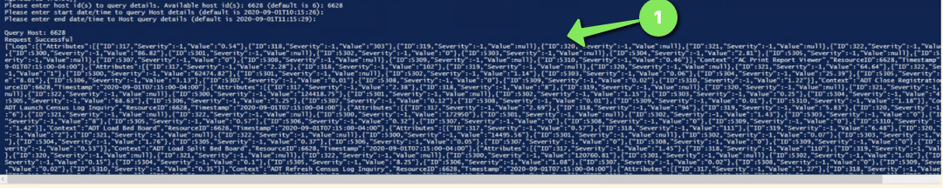

1. If the metric collection is successful, you'll expect to see the text "Request Successful" and then a large block of data. This is shown with call out #1 in the above image.

**Epic System Pulse Monitoring Configuration**

Now that the prerequisites have been collected and then connection has been tested, it is time to configure monitoring for the Epic System Pulse environment(s). The configuration is a two part process 1) Import the Epic System Pulse certificate and then 2) Enable Epic Monitoring

**Import Epic System Pulse Certificate**

1. Ensure you have a copy of the Epic System Pulse SSL Certification file (*.cer) on the Goliath Server, location does not matter
2. Download and install the Keystore tool - <https://keystore-explorer.org/>
   1. Be sure to set the install directory to the agent **JRE\bin** folder
      1. If configuring this on the Goliath Server, the default **JRE\bin** location is one of the following depending on your Goliath version & install directory location
         1. "C:\Program Files (x86)\MonitorIT\vma-api\jre1.8.0_333\bin\KeyStore Explorer"
         2. "C:\Program Files\MonitorIT\vma-api\jre1.8.0_333\bin\KeyStore Explorer"
      2. If configuring this on a machine that is not the Goliath Server the default locations is **"C:\Program Files\MonitorIT\vma-api\jre1.8.0_333\bin\KeyStore Explorer"**
   2. Note, if using the **Browse..** button within the installer then **KeyStore Explorer** will be automatically appended to the end of the path
   3. Now that **KeyStore Explorer** is installed, the import of the certificate can either be done via Command Prompt or the KeyStore Explorer application. See the below sections for the applicable instructions

**Import via Command Prompt**

1. Run Command Prompt as Admin
2. Navigate to the appropriate directory via the appropriate command:
   1. If on the Goliath Server run the applicable command based on your install directory location:
      1. cd "C:\Program Files (x86)\MonitorIT\vma-api\jre1.8.0_333\bin"  
         cd "C:\Program Files\MonitorIT\vma-api\jre1.8.0_333\bin"
   2. If on another machine:
      1. cd **"**C:\Program Files\MonitorIT\vma-api\jre1.8.0_333\bin"
3. Then run the following command to import the Epic System Pulse SSL Certification file into the Goliath Agent
   1. Example:
      1. The red text is the path the the .cer file
      2. keytool -import -alias "epicsystempulse" -keystore "C:\Program Files\MonitorIT\vma-api\jre1.8.0_333\lib\security\cacerts" -file "C:\users\test\Downloads\systempulse.cer"
4. Then you will be prompted to **Enter Keystore Password**, which means you are assigning a password to the Keystore entry. Please enter a password that is at least 6 characters.
   1. You will then be prompted to re-enter the password
5. Next, there will be a prompt for **Trust this certificate? [no]:**, type in **yes** and then hit the enter key to submit
6. You should then be prompted that **Certificate was added to keystore**
7. Close Command Prompt and proceed to [Enable Epic System Pulse Monitoring](https://support.goliathtechnologies.com/hc/en-us/articles/360024294433-Epic-System-Pulse-Monitoring-Configuration-Guide#h_01GNW9BHHK21VVG70NQR8FX7KA)

**Import via KeyStore Explorer Application**

1. Launch the KeyStore Explorer application
   1. Upon launch, if prompted for "Configured CA certificates keystore file foes note exist, use this location instead?" click **yes**
2. Click **File>New** to create a new Keystore
3. A **New Keystore Type** window will open, select **JKS** and then click the **OK** button
4. Select **Tools>Import Trusted Certificate**
5. In the **Import Trusted Certificate window,** navigate to the location where the certificate is saved, select it and click the **Import** button
6. Define an **alias** for the certificate and click **OK.** We recommend using **EpicSystemPulse**
   1. You will be prompted on if the import was successful or if it failed
7. Select File>Save
8. You will be prompted to **Set Keystore Password**, which means you are assigning a password to the Keystore entry.
   1. Password must be at-least 6 characters.
9. A **Save Keystore As** window will appear. Save the keystore to **JRE\lib\security\cacerts**
   1. For example, C:\Program Files\MonitorIT\vma-api\jre1.8.0_333\lib\security\cacerts
10. When prompted to overwrite the existing file, click **Yes**
11. The import is now complete and the application can be closed. Please proceed to the next section.

**Enable Epic System Pulse Monitoring**

1. Click on the **Configure** menu option at the top of the page, and select the **Inventory** submenu option
2. On the **Inventory** page, find and select the line item for the local Goliath Server
3. Click on the **Edit** button at the top of the page
4. A new pane will appear, there will be a section labeled **Epic EHR Monitoring** in this section please do the following:
   1. In the **User Name** and **Password** fields, please enter the credentials for the Read Only Service account for Epic System pulse in the format of **domain\user**
   2. Check the box for **Enable Epic Monitoring**
   3. In the **Epic Server Address** field, please enter the IP Address or FQDN of the Epic System Pulse machine
   4. In the **Epic Production Resource Group** field, please enter the name of the Epic resource group. The default value is "PRD"
   5. In the **Epic Production TypeID** field, please enter the name of the Epic resource group. The default value is "3"
      1. 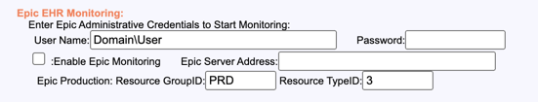
5. Once all information is filled in, click the **Save** button to complete the configuration
   1. It may take about 5 minutes or so before the data will appear

**Post Installation**

From the **Views** tab and clicking on the **Performance Graphs** submenu option allows you to view the dashboard-style performance graphs for Epic.

From the top **Dashboards** section of the left hand menu pane, you can view the Epic System Pulse information collected by clicking on the check box to the left of the folder named **Epic** and then clicking on the large **+** symbol in the middle of the screen labeled **Add Dashboard from Left Pane**

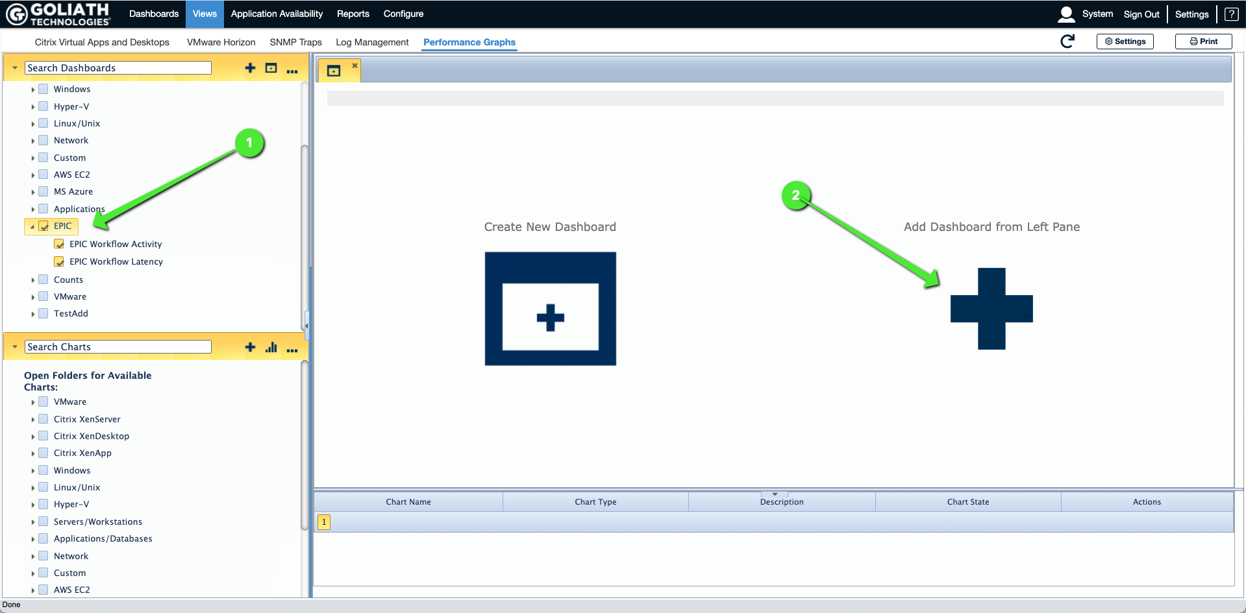

The two dashboards related to monitoring Epic Workflow & Activity will appear and look like this:

